Ajman University Robotics Competition

Guidelines and Project Specifications

General Information
- Three top teams from each high school in UAE can participate in the Ajman University Robotics Competition.
- Each team shall comprise a maximum of 4 high school students.
- Total cost of robot and any additional components/sensors must not exceed AED 800.
- The competition will be held on 4th of November, 2018 at Ajman University.
- First, Second and Third prizes of AED 15000, 10000, and 5000, respectively, will be awarded to the three teams achieving the highest scores as determined by the formula given below.

Introduction

The objective of this competition is to promote students’ skills in designing a robotic project using a ready-made robot that is common for all competing teams. The students can install additional components/sensors on the robot and program the microcontroller to achieve the optimal results as per the specifications given in this document.

Students shall successfully design, implement, and demonstrate the operation of a robot that shall move through an inverted U-shaped route/track (see Figure 1) at a high speed without crossing its boundary and without any collision with objects placed in the path of movement. The total path length will be from around 8 meters. The robot that takes minimum time to reach the parking destination with minimum number of collisions with the objects (obstacles) placed along the route and least number of track boundary crossings, in accordance with the specified formula, will get the highest score and win the competition. The same formula shall be applied to determine the teams securing the Second and Third positions. The competition rules are as follows:

- A total of two attempts will be allowed for each team and the higher score will be considered to determine the team score. The route/track with important dimensions is shown in Figure 1. On the day of competition, it will be marked on the floor by 5 cm wide black tape all along the route. The robot can move freely within the bounded track and for that it may utilize the black tape guidance or any other guidance to avoid crossing the defined boundary of the track. Each boundary crossing will have a penalty (negative score) as specified in the formula for calculating the overall score. A boundary crossing penalty will be applied whenever a part of the robot crosses over the 5 cm black tape. Furthermore, any collision with an obstacle (object) placed in the track will result in a penalty (negative score) as specified in the formula for calculating the overall score.

- The track width is 50 cm and the width of the robot including any installed components/parts shall not exceed 20 cm.

- The obstacles placed along the route will have minimum dimension of 5 cm and maximum dimension of 8 cm on any side of the obstacle.

- The robot shall be placed at the Start Line, as shown in Figure 1, with its front end over the line.

- At their turn, each team will be asked to place its robot on the Start Line. A judge will start the stop watch when the team initiates the movement of the robot. The watch will be stopped as soon as the robot completely crosses the first End Line and parks itself in the designated 50 cm x 30 cm rectangle formed by the first and second End Lines (see Figure 1). The End Lines will be marked with 5 cm wide black tape.

- The Overall Score will be calculated using the following formula:

Overall Score = 100*NT - 3*NC - 3*NV – 4*PV
where,
NT = Normalized Time, NC = Number of Collisions,
NV = Number of (boundary) Violations, PV = Parking Violation
NT = Minimum time taken by a robot / Time taken by the robot under test
NC = Number of collisions between robot and objects placed along the track
NV = Number of boundary crossing violations by the robot
PV = 0 if the robot parks in the designated parking rectangle, otherwise it is 1.

So, a robot that takes the minimum time to cross the first End Line and parks in the designated rectangle without any collision or track violation gets maximum 100 points. In this case, NT will be equal to 1 and all other parameters (NC, NV, and PV) will be zero. This is the ideal design that every team should try to achieve.

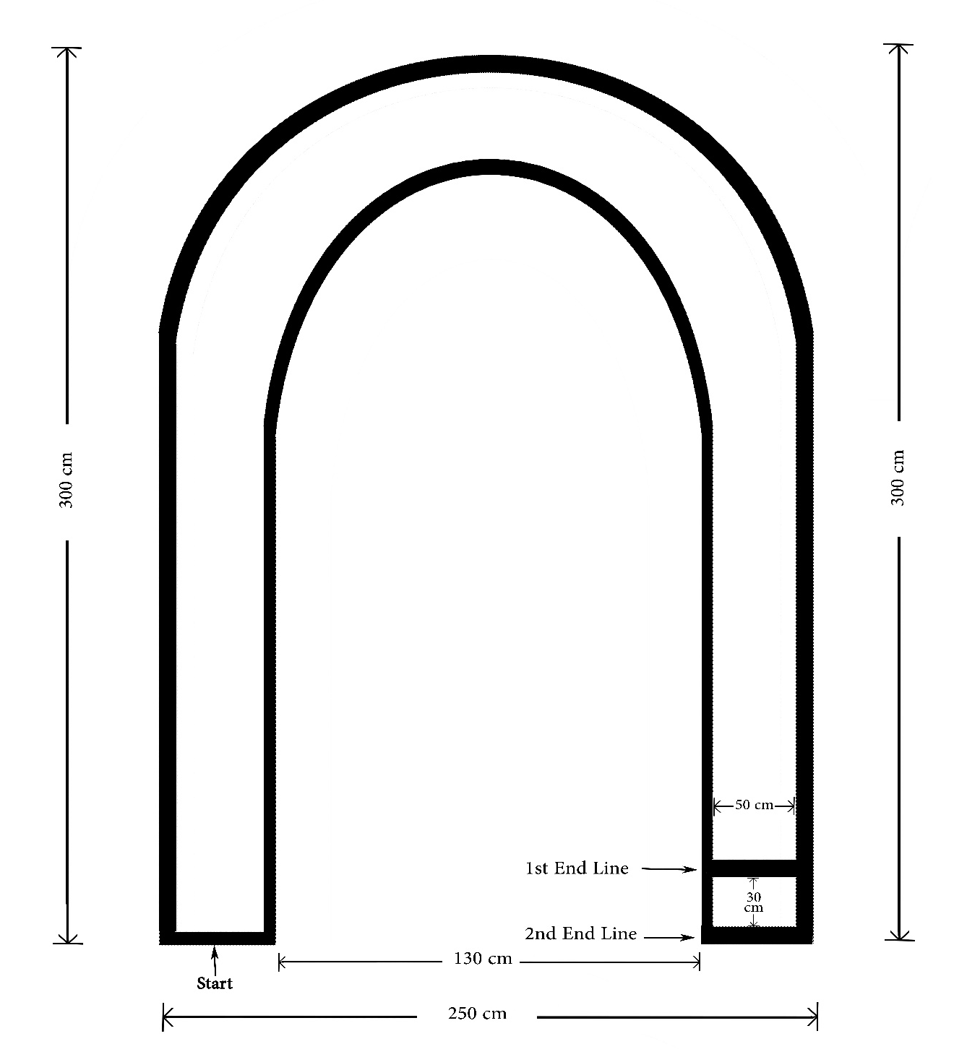
Figure 1

